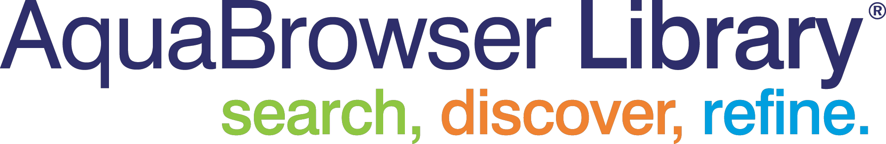

Implementation Process & Tasks
- July 2008



AquaBrowser: Implementation Process & Tasks

Prior to the actual implementation, AquaBrowser will work with your key staff to review the configuration and standard customization options (colours and logo). If you purchase the customisation services, the AquaBrowser Project Manager will work with you and Medialab staff in The Netherlands to accomplish this.
During these discussions and webex sessions, we will identify pre-installation tasks for your Library and us to perform. System integration tasks will be performed by our staff remotely.

Implementation – Sample Timeline

Week 1:
- The Library confirms the order and contracts with AquaBrowser are signed.
- The Library acquires and prepares the server.
- The Library assigns the IP address & server location.
- The Library authorises the Remote Desktop (or VPN) access.
- The Library provides a copy of the bibliographic & holdings data via ftp to AquaBrowser for the initial load.

Week 2:
- Schedule implementation activities.

Weeks 3-4:
- AquaBrowser and the Library complete all action items assigned in weeks 1& 2.
- The first deliverable is made

Week 5:
- Final Implementation and Training activities.

Week 6-7:
- Library staff review functionality and decide on any parameter changes.
- AquaBrowser implements any requested parameter changes
- AquaBrowser addresses any functional issues
- AquaBrowser completes implementation.

This broad outline with actual dates can be changed to suit your calendar constraints (e.g. working around holidays). And, depending on the amount of customisation purchased and the number of add-ons ordered, this schedule may be expanded to accommodate more complex project requirements.

Your AquaBrowser Project Manager will work with you to reach a mutually agreeable timeline for installation.

AquaBrowser will provide the library with the AquaBrowserLibrary Standard
Implementation Workbook. During a kick-off session, we explain the workbook and the choices you have for the configuration.

The first step is for the library to provide a copy of the bibliographic and holdings data in MARC21 or similar format from the current library system. Medialab will set up a first prototype of the AquaBrowser Library site with your data for you to verify. Based on this prototype and your requirement, the Library will with our help specify the configuration items that need to be implemented.

One of the most time intensive parts for the Library is deciding upon the facet configuration. Often we will have a couple of iterations before we settle on the configuration for go live.

For communication purposes we make use of the online project collaboration environment called Basecamp (htp://www.basecamphq.com/)

Integration Services provided by Medialab include:

- Verify and update your Windows Server OS, IIS Web Server software, and install AquaBrowser.

- Set up an automatic nightly import of bibliographic and holdings data in MARC21 or similar format. A complete bibliographic file with holdings is preferred, but if your ILS cannot provide this nightly, a file of changes (dependent upon your ILS output) will be used. In this case Medialab recommends a complete database import be performed monthly. AquaBrowser indexes are reconstructed nightly.

- Set up a real-time deep link to your ILS OPAC for holdings, item status and patron services. We can support a deep link via OpenURL (or any agreed URL format) to your native full record display (which includes links to patron-placed holds and other services).

- Implement configuration as to the requirements of the library.

The full presentation from Anne Prestamo about Oklahoma State University’s AquaBrowser implementation can be downloaded from:

http://gslis.simmons.edu/podcasts/index.php?id=48

